Separation between **entity classes** and **DTO/ViewModel** classes does involve code to move data from one object to another..

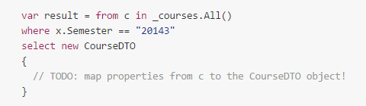

For small classes this is not much of an issue.. but if..

1. There are many props to map to/from..
2. The mapping needs to happen in several places
3. The classes in question might be prone to changes, i.e. we might want to add properties to them which must be mapped..

This could be an issue..

**Move mapping to a central place**.. could involve custom routine.. perhaps an extension method..

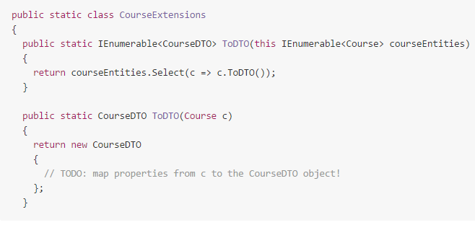

Can become tedious.. can use **AutoMapper..**

Need to specify at startup that we wish to be able to map between certain types..

**Mapper.CreateMap<Course, CourseDTO>();**

An elegant way to set up mapping for each layer of our project.. is to add a mapping file to App_Start folder.

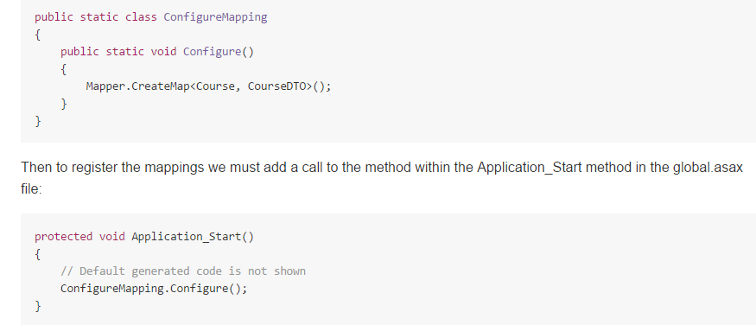

Then when we must map.. we can just..

Var courseDto = Mapper.Map<CourseDTO>(c);